**Big Data project: Washington DC Crime Analysis**

Group Member:

Wei Zhao, Ka Bian, Siddharth Dixit

May/21/2017

Contents

2 Introduction 2

2.1 Background & Motivation 2

2.2 Data source & preparation 2

3 Implementation 3

3.1 Time series analysis in SparkR 3

3.1.1 Setting Spark Context and SQL Context environment 4

3.1.2 Regression Model 6

3.1.3 Final table 7

3.2 DBSCAN algorithm for clustering crime spots in Hadoop 7

3.2.1 DBSCAN algorithm 8

3.2.2 Hadoop implementation 9

4 Result visualization & analysis 15

5 Conclusion & Improvement 26

# Introduction

## Background & Motivation

Crime analysis is gaining increasingly importance since the number of crimes is increasing drastically. This is true especially in Washington DC, with more than 30,000 crime incidents annually. The goal of crime analytics is to gather and analyze recurring patterns in crime. Crime analytics help police intelligently make decisions and proactively plan the defense mechanism. It also helps residents to avoid some accidents. Biggest challenge involved in crime analytics is processing large amount of historical data. If crime analytics can be performed so that the data is processed and patterns are generated out of given data and patterns thus generated if displayed on the GIS based map, can help police personnel and residents in making decisions faster. Hotspots are high concentration areas of some activity. Crime hotspots are concentration of crimes in specific geographical area, recurring over time. Experience of police shows that certain geographical areas called crime generators have high probability of occurrence of crime. Hotspots are areas of imaginary boundary where there is recurrence of crime incidents.

Given the serious nature of crimes, what it is that contains the most value? Our team went over the value that could be derived from crime data and figured out the following to be worth analysing:

1. Time series analysis to predict crimes
2. Crime clustering to predict geo areas for high crime rates

Considering each of these analyses are significantly different from each other, different methods were used to make the analysis and derive value from their results.

## Data source & preparation

The data source is from DC government. We downloaded from the website: http://opendata.dc.gov/datasets/. The data of crime incidents from Jan/01/2011-Apr/30/2017.

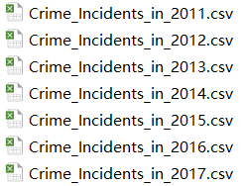

This data set has all the recorded crime incidents in Washington DC. The data have multiple attributes: ANC, BID, BLOCK, BLOCK_GROUP, CCN, CENSUS_TRACT, DISTRICT, END_DATE, LATITUDE, LONGITUDE, METHOD, NEIGHBORHOOD_CLUSTER, OBJECTID, OFFENSE, PSA, REPORT_DAT, SHAPE, SHIFT, START_DATE, VOTING_PRECINCT, WARD, XBLOCK, XCOORD, YBLOCK, YCOORD. Those attributes can be categorized into 3 categories: the description of the crime, time and location. Every year has around 30,000 incidents, with 11,000 for the first 4 months of 2017.There are 228,455 records in this dataset.

We used Spark to process our data. To analyze the trend and seasonality of the Crime, we counted the number of incidents monthly. The final data set shows the month, the number of incidents, numbers representing trend and numbers representing the month. Besides, when we were analyzing the location information, we chose the longitude and latitude. This choice has many advantages: it facilitates the calculation of distance in DBSCAN algorithm and visualization of clustering. XCOORD and YCOORD, represented by MAR Geocoder, also show the accurate geographical information of crime incidents, but this geocode is not acceptable for the ArcGIS. The final data set only has the longitude and latitude. Considering the capacity of the Hadoop, we only used the 11,000 incidents in 2017 to do the Density-based spatial clustering.

# Implementation

## Time series analysis in SparkR

To run SparkR, we were able to implement a Spark Context and SQL Context environment within R studio using the SparkR package available within SPARK_HOME, using R Studio as the framework.

### Setting Spark Context and SQL Context environment

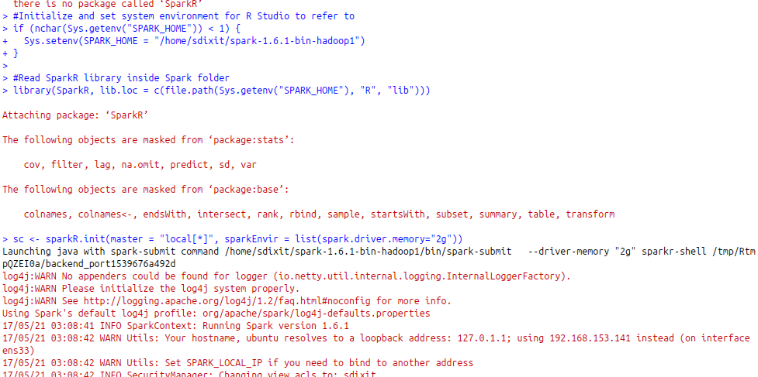

In the image above, we can see that SparkR is loaded in R Studio. After that, we set sc as the Spark Context, create SQL Context from sc and initialize our table using this SQL Context environment:

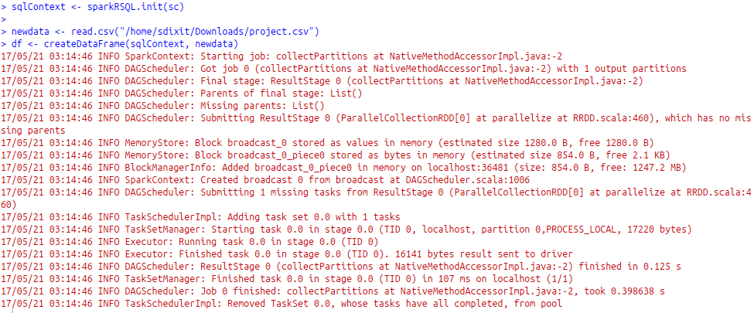

Hence, the SparkR dataframe df contains all the data from project.csv but stores it in sqlContext. In the image above, ‘newdata’ is the intermediate R dataframe created by simply reading the csv file.

The new df looks like this:

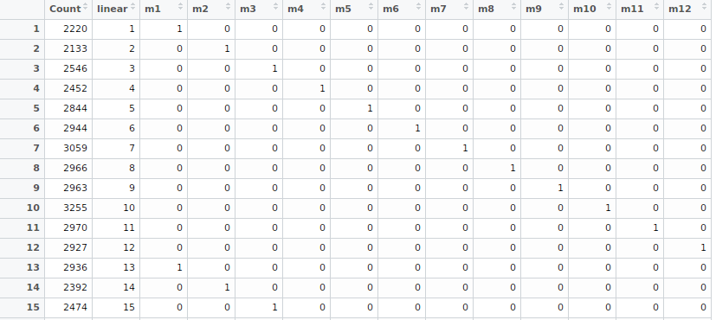

Then, we run the logistic regression function, which is the preferred function for time series regressions as it can easily take into account the seasonal and linear component (linear model cannot take seasonal component without large error). Upon running the logistic regression model, we get:

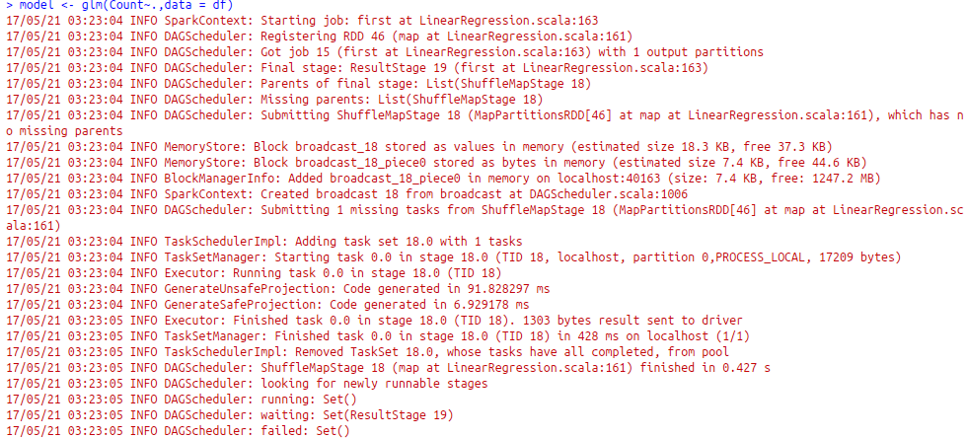

Upon summarizing the model, we see all the coefficients as follows:

predicted <- predict(model, df)

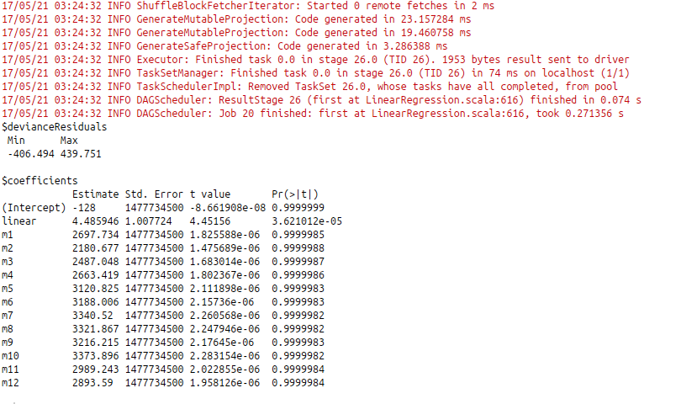

Here we see the coefficients for all months (seasonal, repeating every year) as well as the linear components (effect with increase of every single month on crime number).

### Regression Model

Predicting results using regression model:

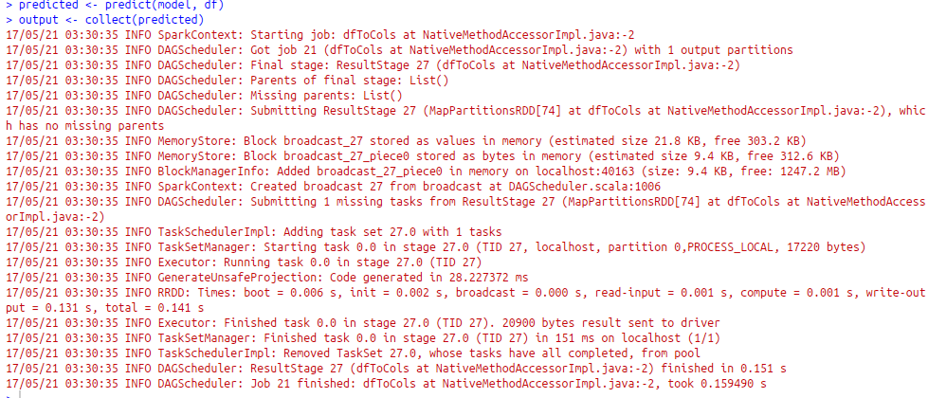

Notice how the ‘collect’ function in the above image uses the sqlContext dataframe and converts it to an R data frame that can be written as a csv file and used for analysis on front end.

### Final table

The final table looks like this:

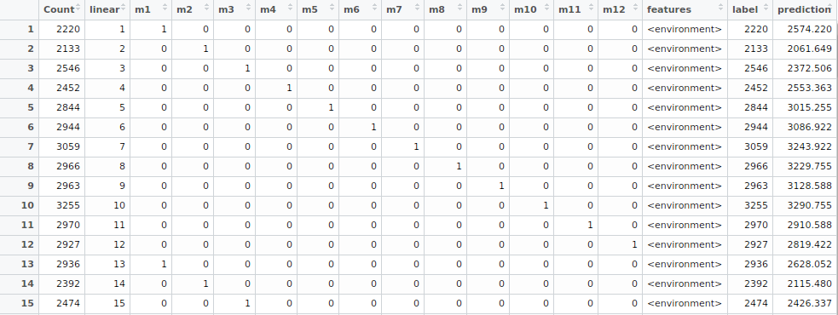

## DBSCAN algorithm for clustering crime spots in Hadoop

### DBSCAN algorithm

DBSCAN is short for density-based spatial clustering of applications with noise. As we can see from its name, it is very useful for spots clustering. Washington DC crime spots have geo spatial information are easy to acquire.

In DBSCAN, there are two main parameters: radius and minPoints. For each point P in a given area, its neighborhood is the set of all the points around it within radius distance. If the number of points is no smaller than minPoints, then all the points in this set as well as point P are in the same cluster. In this cluster, P is called core point, while the other points are called neighbor points.

For each point in the neighbor of point P, using BFS algorithm to repeat the same core point identification method until the cluster can no longer be expanded. In a given data set, when all the points are marked visited, the clustering is finished. After performing DBSCAN, several clusters are found in the dataset and for those points which are not contained in any cluster are called noise points. They are also called outliers. In conclusion, every point in data set is assigned to a cluster or marked as a noise point. The following figure shows how DBSCAN is performed.

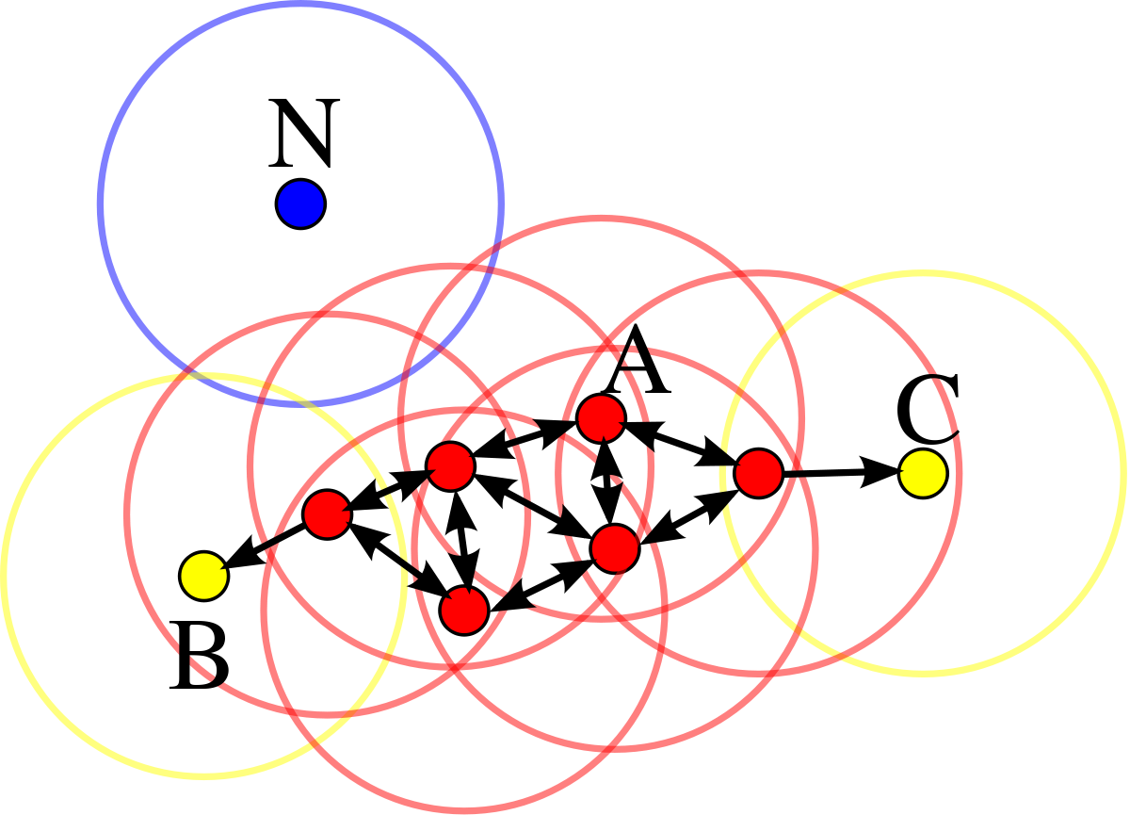

(Reference: https://en.wikipedia.org/wiki/DBSCAN)

In this diagram, Point A and the other red points are core points, because the area surrounding these points in the predefined radius contain points at least minPoints (including the point itself). Those points form a single cluster. Points B and C are not core points, but are reachable from A (via other core points) and thus belong to the cluster as well. Point N is a noise point that is neither a core point nor density-reachable. All points not reachable from any other point are outliers.

Compared with K-means, DBSCAN has several advantages as follows:

* DBSCAN can group data into arbitrarily shaped cluster
* Unlike K-means, it doesn’t need to set number of clusters in advance.
* DBSCAN can identify outliers
* It is insensitive to the input order of the points in the dataset

Those advantages make DBSCAN as the most appropriate clustering algorithm for our analysis. Our research focus on the density of crime occurrence. Location of crime incidents will be assigned into different clusters according to the density of adjacent area.

### Hadoop implementation

#### DBSCAN in MapReduce

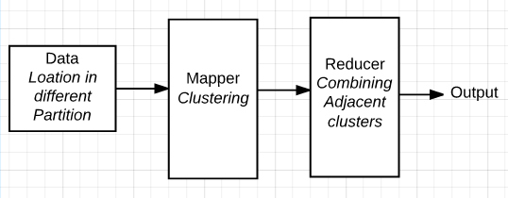

Due to the large size of dataset and the space complexity of the algorithm, it is necessary to perform DBSCAN in parallel to reduce processing time. In this scenario, MapReduce implementation in Hadoop is a good choice to process such a big data set.

#### Data Preparations

We chose recently 11,000 incidents of crime from Jan 2017 to April 2017. Each data in data set is recorded by its longitude and latitude. Data are partitioned as evenly as possible based on their location. We have 14 partitions in total. For each partition, there are around 1000 points. After partition, the whole data set is saved as a text file and uploaded to HDFS.

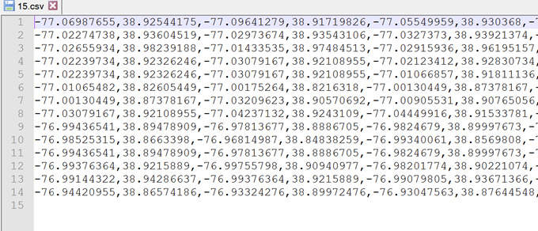

(Input files)

#### Mapper Design

Map is used to build parallel clusters. It performs reading a line of string from input file and parse it into points. After DBSCAN in each partition, the point and its cluster information outputs as MapOutValue.

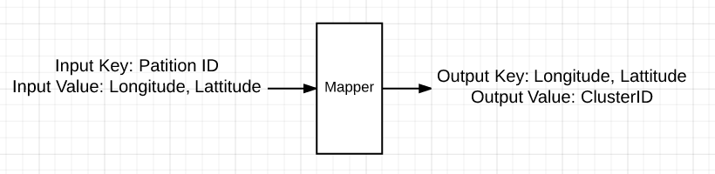

**Input Key**: PatitionIndex

**Input Value**: Points in Partition

**Output Key**: Points

**Output Value**: ClusterID

PatitionIndex is the offset. In map input text, each line is one partition. Each line has around 1000 points. Point is a new class. It contains information of Longitude, Latitude, PartitionIndex and ClusterID. In our design, output value is a new class too, called MapOutValue. The role of this output records the ClusterID, PartitionID, and merge information.

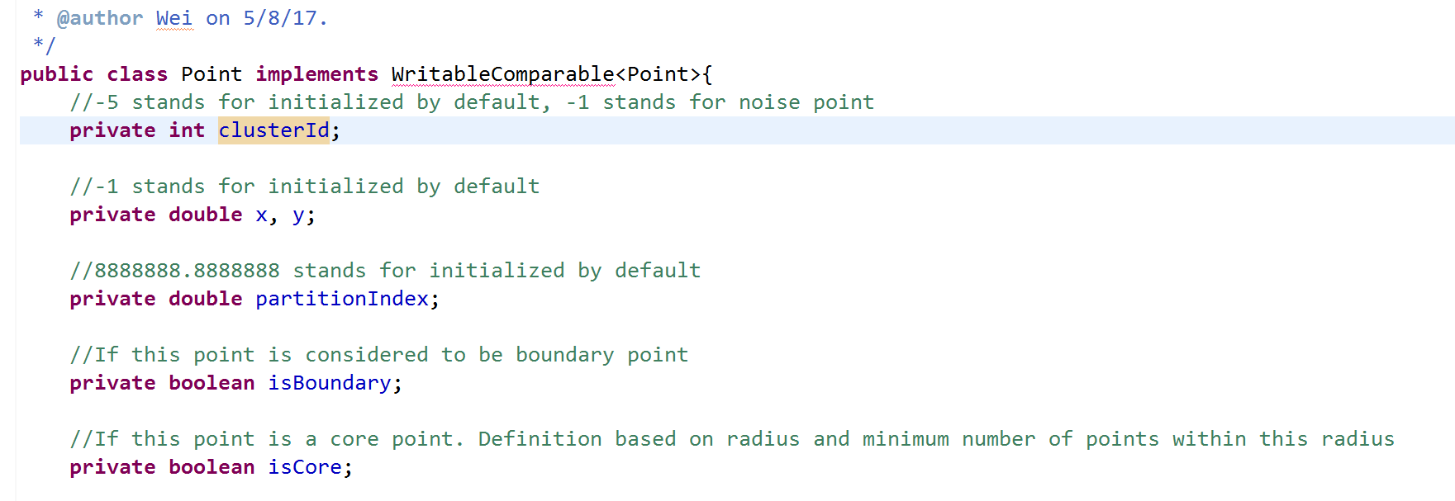

Class Point

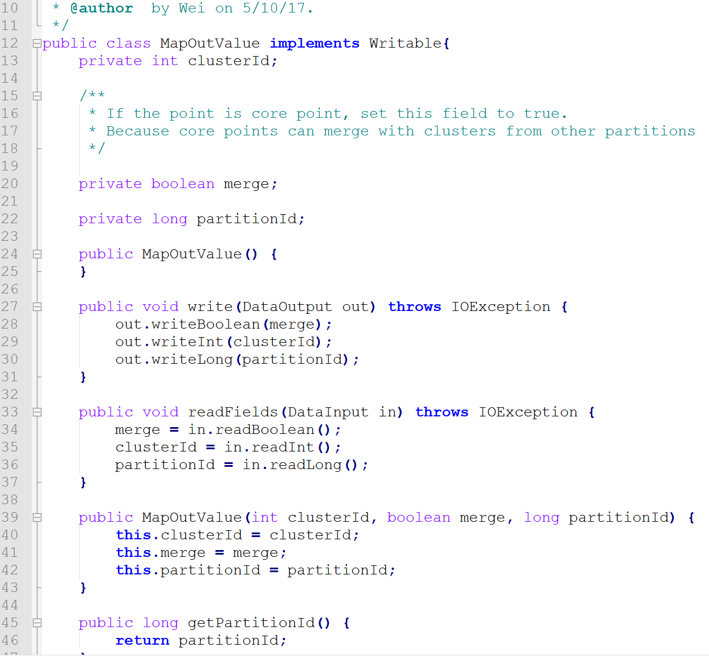

Class MapOutValue

There are overall 3 stages for implementing DBSCAN in Map.

1 Calculate distance of all points between each other (O (n2) Time & Space complexity)

2 Find all neighbors of each point (O (n2) Time & Space complexity)

3 Do BFS to points and build cluster

When we calculate the distance of all points between each other, we used longitude and latitude to calculate the distance. The method is derived from google map API as follows, the return unit is KM.

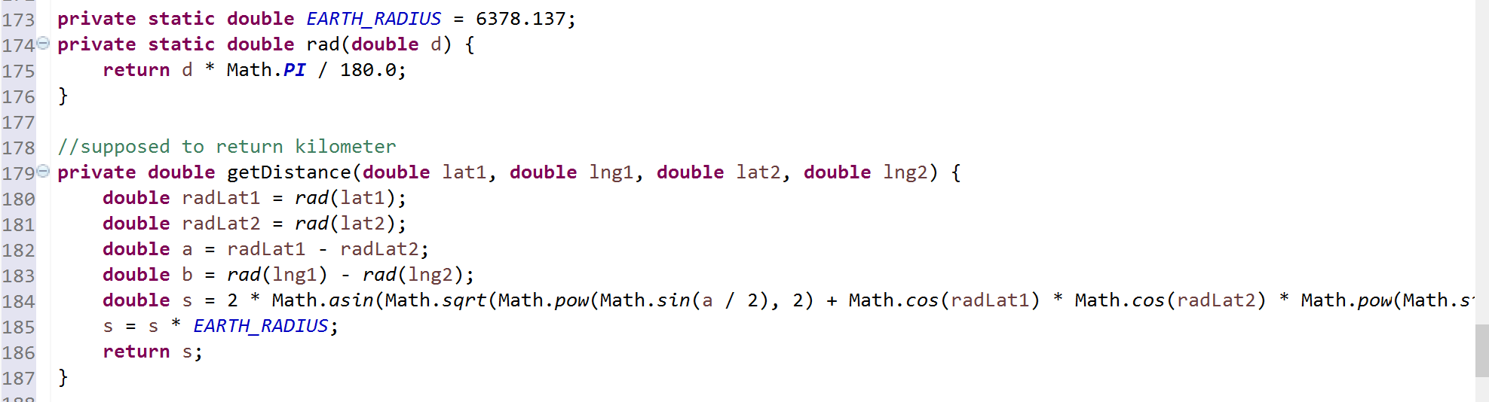

When building clusters, we initially set the radius = 0.5Km, minPoint = 15. Each point in one partition is marked as unvisited at the beginning. For each single point, if there are less than minPoints within the distance radius, the point is marked as a noise point with clusterID = -1. If one single point has at least minPoint in its neighborhood, then the point is marked as a core point. All the points in its neighborhood is visited by using BFS algorithm to identify whether it is a core point or not. As the cluster expands, all points are marked visited. When the cluster cannot expand anymore, a new cluster ID has been created. When all the points in one data set are all being visited, the DBSCAN is finished. After DBSCAN, the output of map has local ClusterID as well as partitionID to represent Global clusterID.

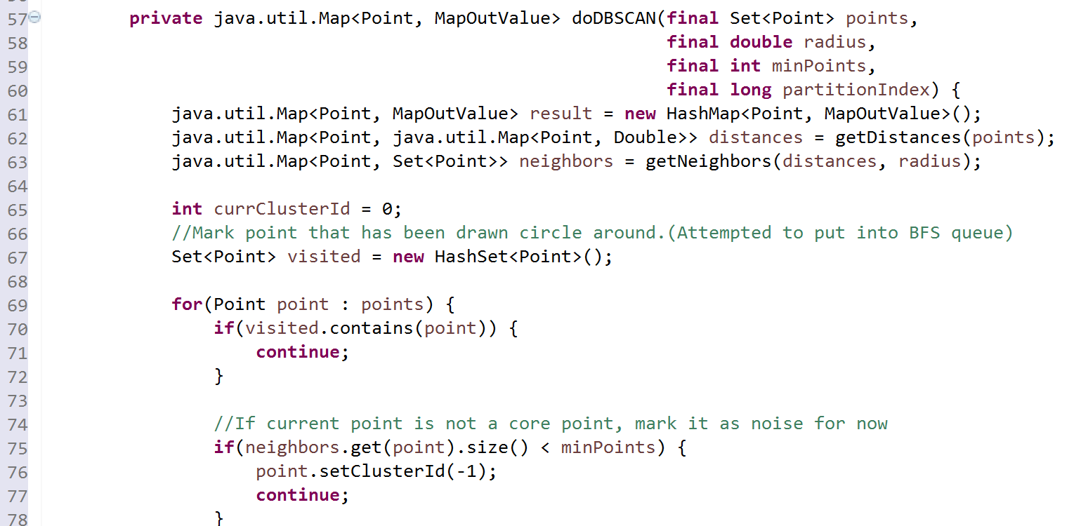

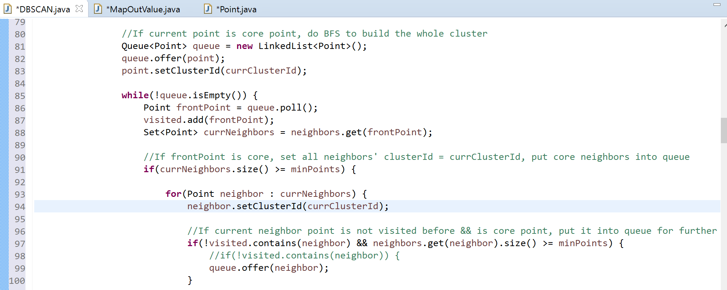

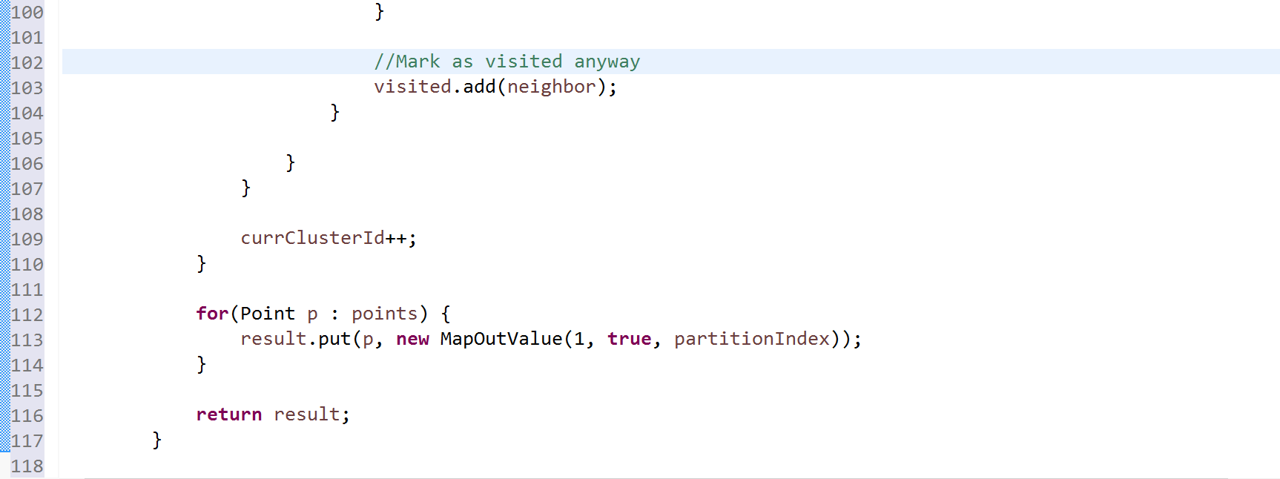

Screenshot of DBSCAN implementation

#### Reducer Design

Reduce is used to read the output of map into HDFS. After map implementation, each partition is being clustered with partitionID + clusterID as its global clusterID. In reduce each cluster information is write to HDFS.

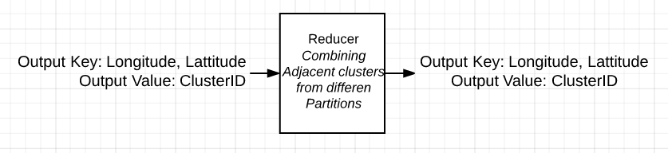

**Input:** Output of Map

**Output Key:** Point

**Output Value:** ClusterID

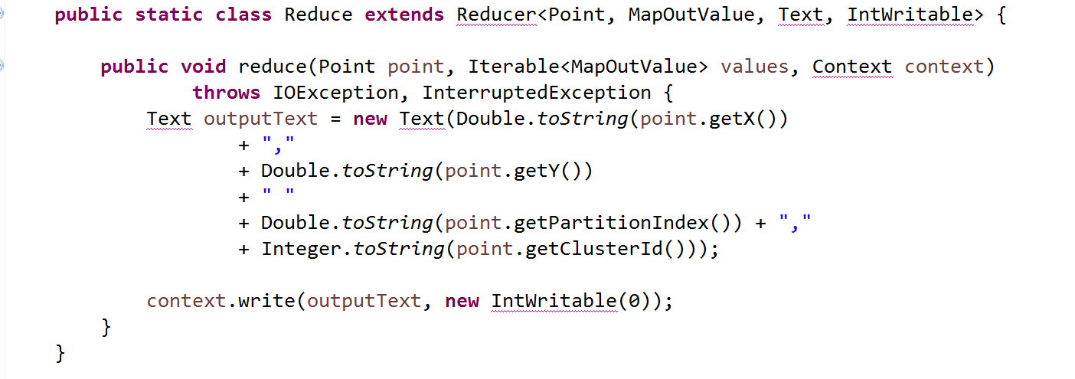

This Java syntax can realize the function of reducer.

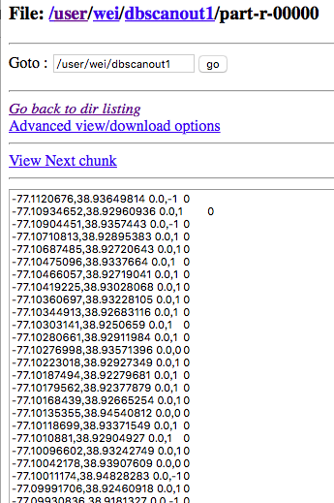

The results in HDFS are shown above. In each line, every point is followed by its clusterID. Each clusterID is a string consists of partitionIndex as well as local clusterID.

We can enhance reduce function later by realizing merge of two adjacent clusters. When dividing input data into 14 partitions, we have already considered merge problem. As a result, we have doubled the points in boundary of two partitions. In other word, two adjacent partitions both have data points on their boundary. In our design, class MapOutValue can record information of whether the point should be merged or not. The criteria of a merge point is: the target point is contained in two adjacent clusters at the same time it is a core point. After two cluster is merged, a new global clusterID should be created.

# Result visualization & analysis

We use R studio to plot Actual (Red line) vs Predicted (blue line):

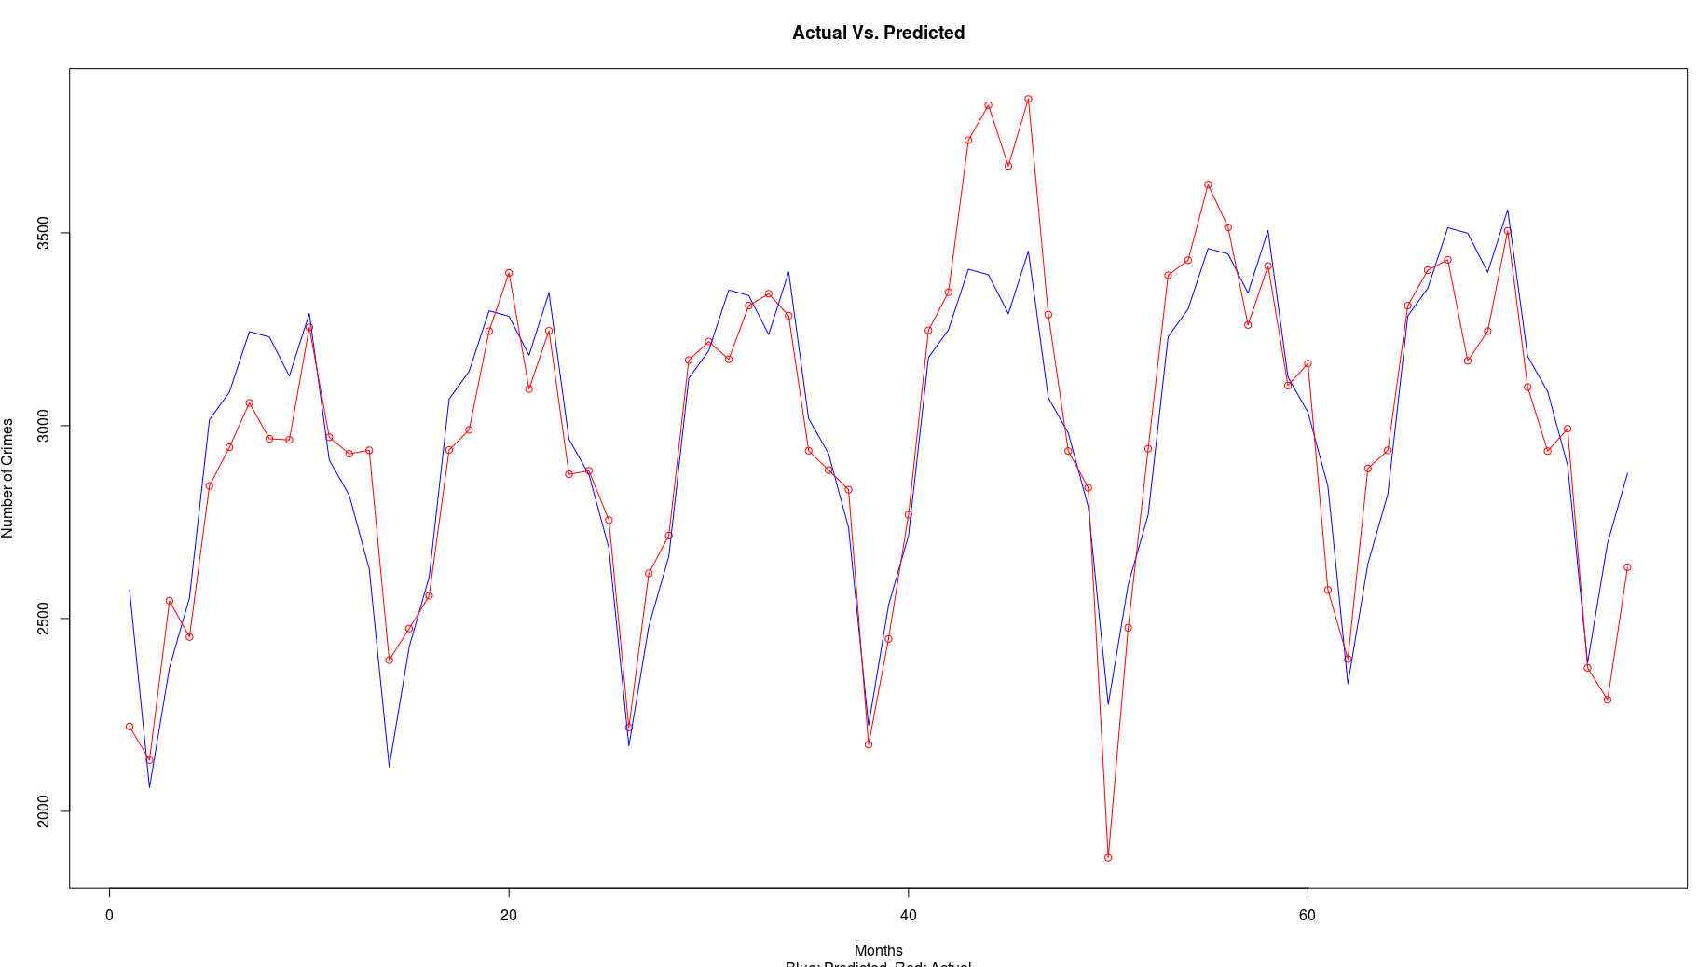

Now that we have the output values, we just need to create the front end in Shiny using R. R Shiny is a package in R that makes use of apps containing two R scripts:

1. ui.R
2. server.R

Once these two files have been created and modified, our R page looks like this:

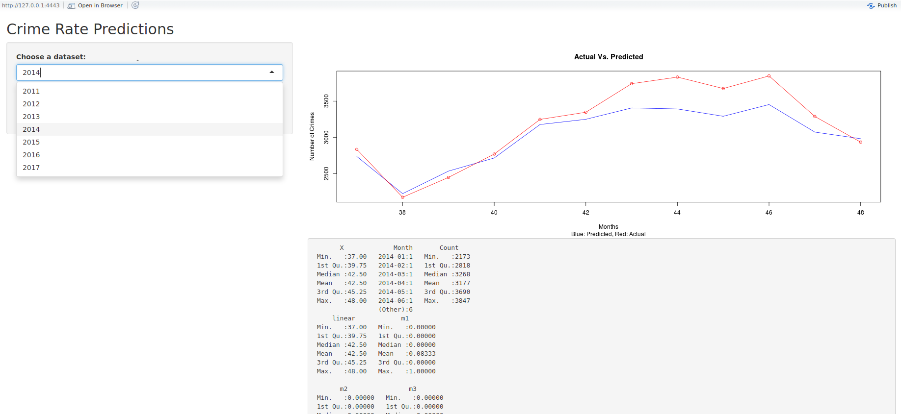

We have an interactive dropdown menu where we can select any year and look at actual crimes vs predicted crimes as well as the summary data to view the mean and deviations in data.

In location analysis part, the results of the MapReduce show the location information, as well as the partition and cluster. One partition may have zero to many clusters. Different number means different partitions. If the number of cluster is -1, that point is a noise point. The same number of cluster in each partition above or equal to 0 means the same cluster.

Before we do the clustering, the 11,000 are in chaos, showing no laws.

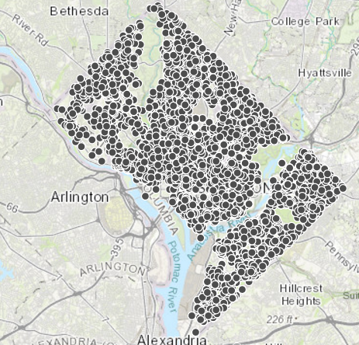

When the radius= 0.1 KM and the minimum number of points=15, all points become noise points.

When the radius= 0.5 KM and the minimum number of points=15, all points become noise points. The results of the MapReduce are showed below. There are totally 9 clusters.

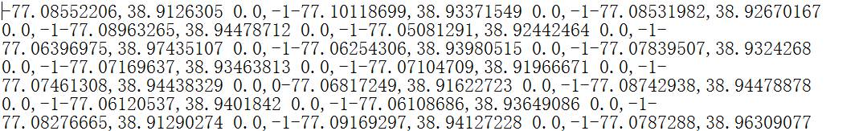

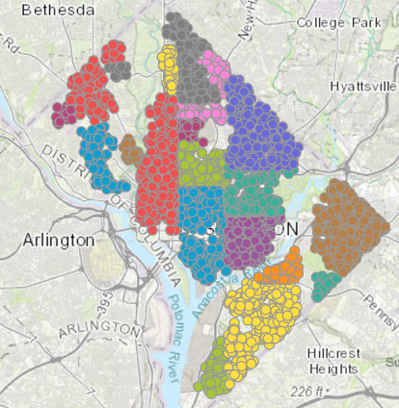

When visualizing the results, we assigned different color for different clusters. In the west of Rock Creek, there are five clusters. In the middle of DC, clusters are jointed together, forming a big cluster. In the east of Anacostia River, there are two big clusters and one small cluster.

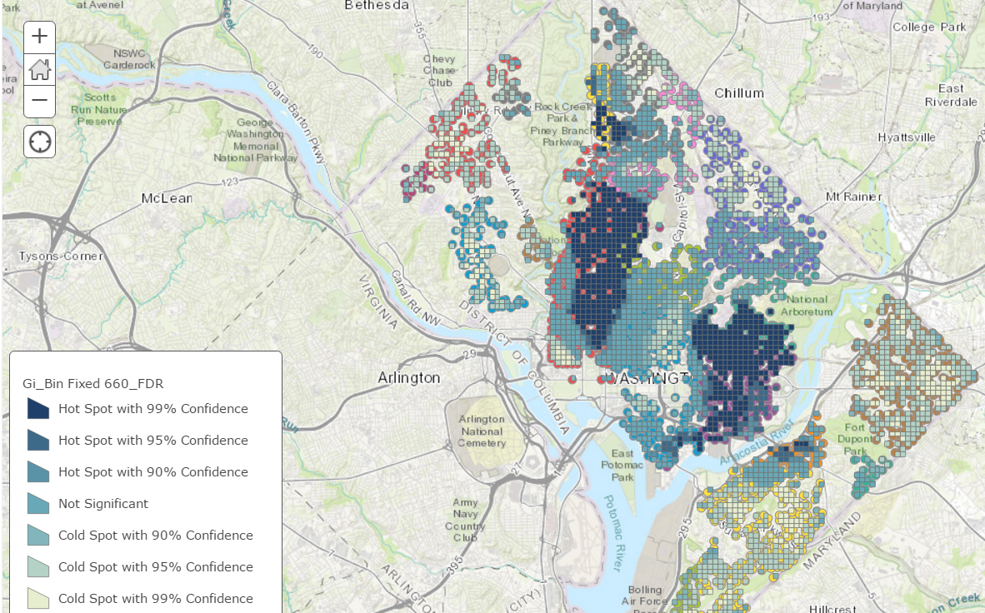

We also used Arcgis to show hotspots with confidence level. The dark area has the dense concentration of crime incidents. Most Crime hotspots are distributed in northwest and west of downtown DC.

When the radius= 0.5 KM and the minimum number of points=25, all points become noise points. The results of the MapReduce are showed below.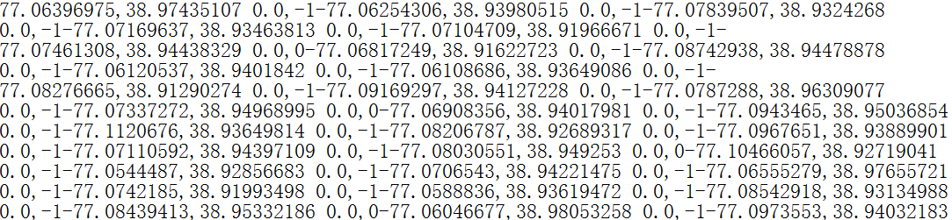  
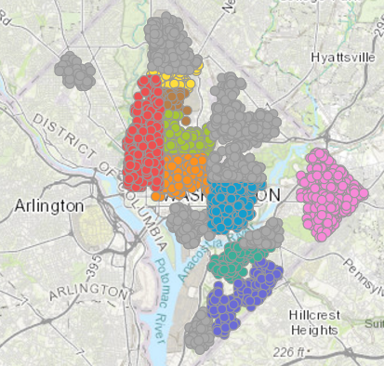

With the increasing of standard of forming a cluster, there are less clusters compared the the first run. The boundaries between different clusters become clear.

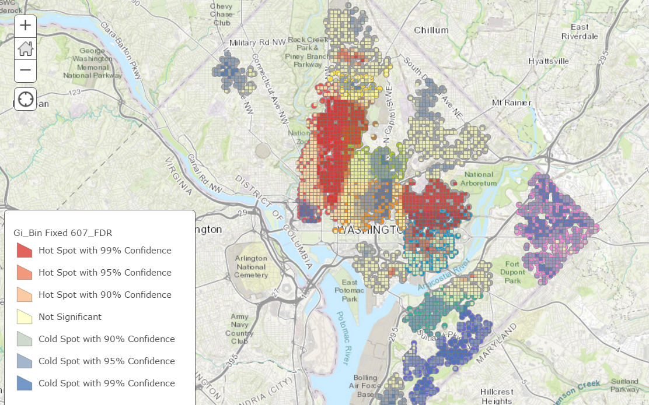

In searching of crime hotspots,we draw this map. The hotspots are almost in the same area with the previous map, but the scale of hotspots has been decreased.

When the radius= 0.5 KM and the minimum number of points=50, all points become noise points. The results of the MapReduce are showed below.

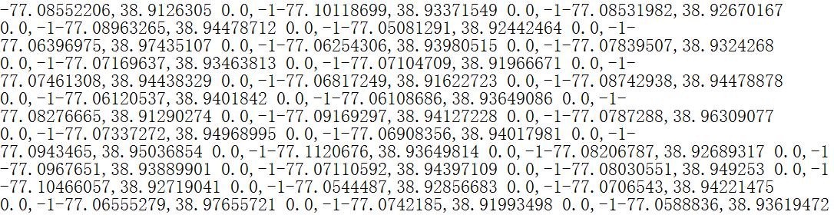

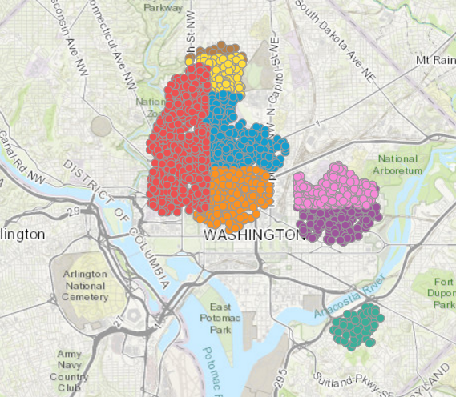

There are only 3 clusters. The biggest one in the north of downtown DC; the second largest one in the northeast of downtown DC; the smallest one is in the east of Anacostia river.

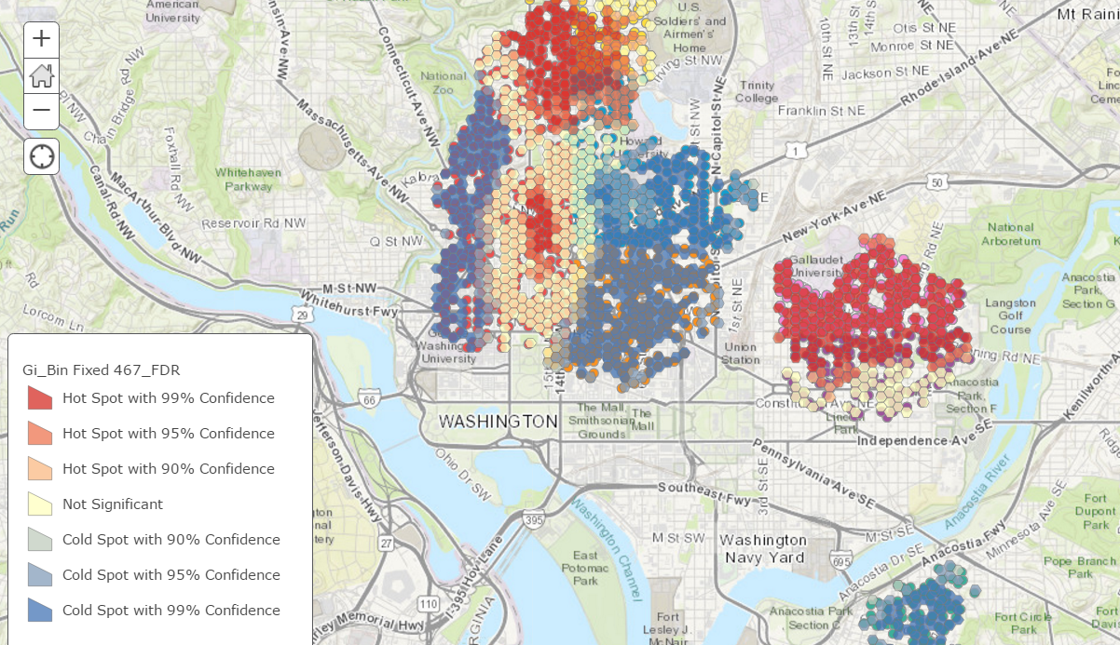

The red points(crime hotspots) with high density are clearly shown in the map above. Neighborhood of those points has the largest density.

When the radius= 0.5 KM and the minimum number of points=75, all points become noise points. The results of the MapReduce are showed below.

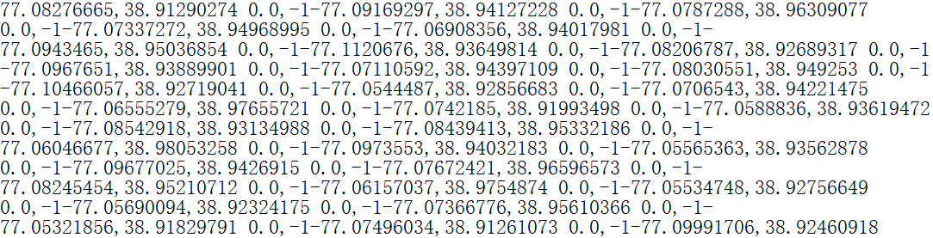

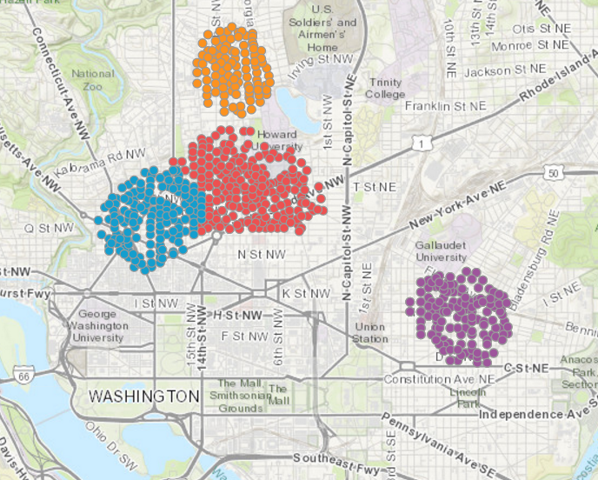

There are only 3 clusters. The biggest two clusters are in the north of downtown DC; the smallest one is in the east of downtown DC.

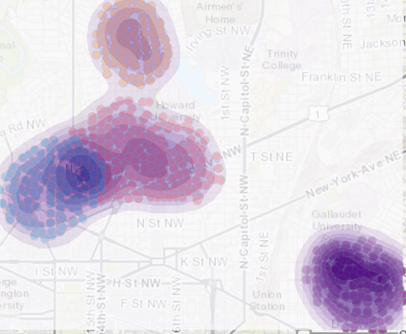

In this map, we can see there are 4 crime hotspots, with the highest density. Crime incidents in DC have large possibility to occur around those four crime hotspots.

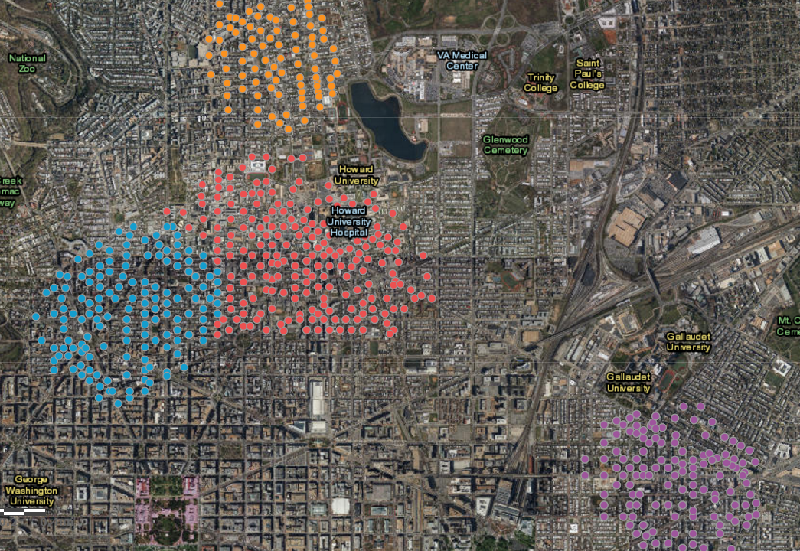

Area around crime hotspots mostly is residential area, with high density of population which is the main reason of high crime occurrence.

Above all, the crime hotspots in DC are in the north and east of downtown DC.

# Conclusion & Improvement

Our implementation of time series model and Density-based spatial clustering of applications with noise (DBSCAN) achieves the ideal goal. We have deep insights into the big data of crime occurrence in Washington DC. However, our Java execution on Hadoop still has room to improve. When reducer can perform perfectly, the clusters from adjacent partitions can be merged into one cluster if it meets the rules of DBSCAN.

After our analysis, we find some regularity of crime incidents in terms of time and location. According to the results of our research, we also give recommendations to police station and residents of DC.

To begin with, time of crime occurrences have a repetitive pattern of time. The total number of crime incidents remained almost the same during the 7 years. However, the seasonality of crime occurrences is obvious. Some characteristics of crime frequency are as follows: highest Crimes occur almost every year during: July (~2100), lowest Crimes occur almost every year during: February (~3300). The linear coefficient is 4 (small compared to other coefficients), meaning that crime increases very little to almost not at all every month. Still, this adds up over several years and slight increase of crime can be observed. The MAPE (Mean Absolute Percentage Error) between the predicted and actual crimes is just 4.72 %, meaning crime is predicted to a high degree with current data. Hence, this data can be relied upon to predict the severity of police patrols in future months as well.

Secondly, crime incidents have higher rate of occurrence in some specific area. Crime clusters in different levels are found when different parameter are applied. Supposed the radius ramian at 0.5 KM, when the miniPoint is low, the cluster is large. The cluster will become smaller with the increase the of miniPoint. When miniPoint=75, we found 4 crime hotspots. Both of them are residential area in the middle north of downtown DC. Experience of police shows that certain geographical areas called crime generators have high probability of occurrence of crime. Police can take proactive actions such as assigning more force at crime hotspots. Residents should also instantly contact police when crime happens.

We will keep our research going and try to yield more outcomes that would help minimize the occurrence of crime.